Six Ways You Can Help Earthquake and Tsunami Victims in Japan

By: Megan Gibson
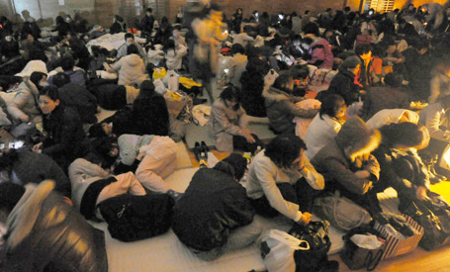
The first thing on most peoples' minds after they hear the news of a horrific disaster (like the earthquake in Japan) is, what can I do to help?
Even if you're hundreds of thousands of miles away, there are various ways that you can offer your support to the earthquake and tsunami relief effort. Here are just a few of them:
The Red Cross: The Japanese Red Cross has already deployed 11 national disaster response teams to respond to the crisis but you can support their efforts by donating money. Similar to their efforts to help Haiti after the earthquake in 2010, Red Cross is accepting donations either online or via text message. Simply text REDCROSS to 90999 to donate $10 from your phone (you'll be prompted to confirm with a second text reading YES).
Shelterbox: The UK-based organization has 18 international affiliates and it has launched an online fundraiser for the earthquake and tsunami relief efforts. Shelterbox provides assistance to afflicted countries by delivering large utility boxes that contain a shelter and other emergency relief tools. To donate online, simply go to your country's site and click DONATE.
International Medical Corps: To donate to this global non-profit's Emergency Response Efforts fund, simply go to their site and select the amount you wish to donate (be sure to note if you want your donation to be a "recurring gift" for future relief efforts) and fill in your information.
GlobalGiving.org: Working with other organizations such as the International Medical Corps, D.C.-based organization GlobalGiving has launched the Japan Earthquake and Tsunami Relief Fund, which will give aid to on the ground organizations providing emergency services. They are accepting donations online with a funding goal of $90, 000.
Convoy of Hope: This non-profit focuses on disaster relief efforts and you can donate either online at their site or via text message by texting TSUNAMI to 50555 (you'll also be prompted to confirm with a follow up text of YES).
UPDATE: We've been hearing of more organizations that are leading the way in helping victims of the earthquake and tsunami so we'll be updating this list as they come in. If you know of more organizations that are doing great work and need help with donations, aid or volunteers please let us know.
Salvation Army: The Japan branch of the Salvation Army has been working in Tokyo to offer shelter to stranded commuters and they are reportedly organizing a team to send to Sendai Friday night. They also have their Hawaii branch standing by, ready to help. You can help their relief efforts by texting JAPAN or QUAKE to 80888 to make a $10 donation.
http://newsfeed.time.com/2011/03/11/five-ways-you-can-help-earthquake-and-tsunami-victims-in-japan/

